Exemplu

lu

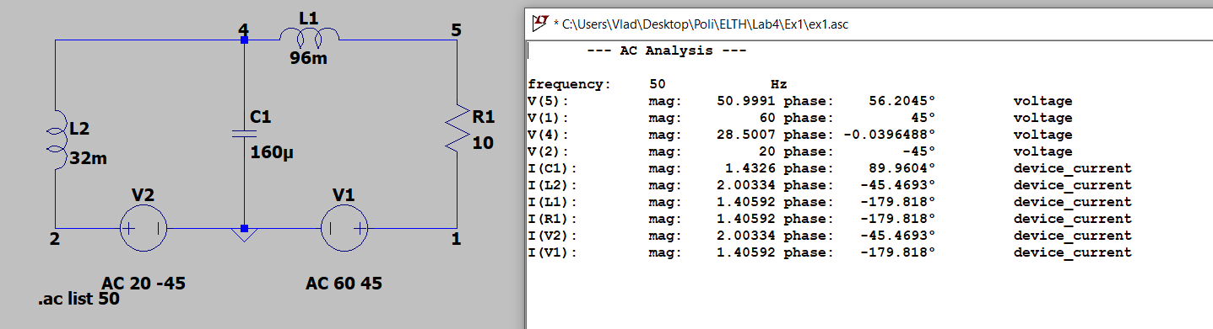Exercitiu 1

Exercitiul 2

Exercitiu 3

